**Mini Project Report On**

**“DriveEZ”**

**submitted in partial fulfillment of the requirements for the award of the degree of**

**BACHELOR OF ENGINEERING**

**(Computer Engineering)**

**By**

**1. Chaitanya Deshapande 39023.**

**2. Vedant Deshpande 39024.**

**3. Jay Dixit 39027.**

**UNDER THE GUIDANCE OF**

**Mr. Santosh Nagargoje**



**Department of Computer Engineering**

**PES’s Modern College of Engineering, Pune-05**

**2019-2020**



**Department of Computer Engineering**

**Progressive Education Society’s**

**Modern College of Engineering, Shivajinagar, Pune-05**

***CERTIFICATE***

***This is to certify that the project entitled***

***“DriveEZ”***

***Submitted by***

***Chaitanya Deshpande 39023***

***Vedant Deshpande 39024***

***Jay Dixit 39027***

***is a bonafide account of the work done by him/her under our supervision.***

**Project Guide/Internal Examiner HOD**

**Mr. S. N. Nagargoje Prof. Dr. Mrs. S.A. Itkar**

**External Examiner**

**Acknowledgment**

I take this opportunity to express my profound gratitude and deep regards to my guide Mr. Santosh Nagargoje for his exemplary guidance, monitoring and constant encouragement throughout the course of this project. The blessing, help and guidance given by him time to time shall carry me a long way in the journey of life on which I am about to embark.

I also take this opportunity to express a deep sense of gratitude to Prof. Dr. Mrs. S. A. Itkar (Head of Department) for her cordial support, valuable information and guidance which helped me in completing this task through various stages.

I am obliged to staff members of PES MCOE, for the valuable information provided by them in their respective fields. I am grateful for their cooperation during the period of my assignment.

Lastly, I thank almighty, my parents and my classmates for their constant encouragement and technical help without which this assignment would not have been possible.

**Abstract**

According to the Ministry of Road Transport and Highways, 150,785 people were killed and another 494,624 were injured in 480,652 road crashes in India in 2016. The National Safety Council reports that cellphone use while driving leads to 1.6 million crashes each year. Nearly 330,000 injuries occur each year from accidents caused by texting while driving. Distracted driving has been identified as an important risk factoring road traffic injuries. In 2015 alone, 3,477 people were killed, and 391,000 were injured in motor vehicle crashes involving distracted drivers. Mobile phone usage has developed into a primary source of driver distraction as it can induce drivers to take their attention off the road, thus making vehicle occupants more vulnerable to road crashes.

To minimize the risk of accidents caused due to the use of cellphones while driving, this application uses a variety of strategies to keep the driver’s eyes on the road. The application incorporates various features that makes it the best partner for every road trip.

**Table of Content**

|  |  |  |
| --- | --- | --- |
| **Sr.No** | **Name** | **Page No** |
| **1** | **Introduction** | **6** |
| **2** | **Objectives** | **7** |
| **3** | **Methodology** | **8** |
| **4** | **Software / Hardware requirement** | **9** |
| **5** | **Implementation Details** | **10** |
| **6** | **Diagrams** | **11** |
| **7** | **Conclusion** | **15** |
| **8** | **Future Scope** | **16** |

**Introduction**

**Motivation:**

To overcome the problem regarding accidents caused due to handling of phones while driving, we propose a Drive Mode Road Safety Android Application. A modern survey says that 75% of Indian population uses Android smartphones. So, considering that, we have created an Android application that will help to minimize the risk of accidents caused due to the use of cellphones while behind the wheels. This application uses a variety of strategies to keep the driver’s eyes on the road. The application incorporates various features that makes driving safe.

**Problem Statement:**

To develop an android application that will block all incoming calls while user is driving and send autoreply to caller and help the user in tracking his/her previous ride details.

**Objectives**

1. **To develop an application that will block all incoming calls while the user is driving.**

All the calls and messages will be blocked when speed reaches 20km/hr.

1. **To auto enable the drive mode when the speed exceeds 20kmph.**

The drive mode is automatically enabled after the speed reaches above

20km/hr.

1. **To setup auto reply to text messages while driving.**

Set up auto reply text message**.**

1. **To facilitate Emergency Call for the callers.**

Add numbers in emergency contact list.

**Methodology**

1. **Calls and message blocking:**
   * All the calls and messages will be blocked when speed reaches 20km/hr.
   * In order to prevent any distraction while driving.
   * An overlay is added to the screen in order to prevent any interaction with the

Mobile.

1. **Drive mode is disabled.**
   * This is to ensure that the driver does not miss any calls or messages that he

received while the drive mode was enabled.

1. **Auto enable drive mode:**
   * The drive mode is automatically enabled after the speed reaches above

20km/hr.

* + This is to ensure that driver does not have to enable the drive mode every

Time.

1. **Auto reply text message:**
   * Set up auto reply text message.
   * The caller is notified with the auto reply text message that the driver had set

Previously.

1. **. Emergency caller:**

* Add numbers in emergency contact list.
* Caller from emergency contacts will be able to call driver

.

**Software and Hardware Requirements**

**Technology Stack:**

**Technology used in Android app**

* Google’s Android API
* Android API provided in open source tools like Android Studio and

Eclipse will be primarily used to develop the GUI presented to the user.

**Technology used in Auto Enable Drive Mode**

* Google’s Maps API
* Google’s Map API for android makes use of Google play services

Present in an android phone to develop location aware app.

* In our app, the Google Maps API is used for determining the speed of

The moving vehicle.

**Technology used for emergency contact:**

* SQLite Database for storing contacts.

**System Requirements**

|  |  |
| --- | --- |
| Software Requirements | Android version 5.0 & above |
| Hardware Requirements | RAM 1GB (min.) |

**Implementation Details**

1. **Drive Mode Enable:**

There are two ways to enable drive mode.

1. Enable drive mode manually –

This can be done by clicking ‘Drive mode enable button’.

1. Automatic drive mode –

If you want drive mode to enable automatically after speed reaches 20Km/hr, you have to enable a switch.

After that drive mode get enable. In drive mode all the calls will get blocked and auto reply is send to caller. If the caller is in the list of emergency contact that call only get accepted.

1. **Auto reply Text:**

There is facility to write your own reply message. You can write your own reply message and save it, so in drive mode caller will receive auto reply message that you set.

1. **Emergency contact:**

User can add emergency contact number. If caller is from emergency contact list then that call does not get rejected. To store emergency contacts we used SQLite database.

User can Add contacts and delete contacts as well from emergency list.

1. **Additional Functionality:**

User will be able to dial emergency number while ride mode is ON • If speed is greater than speed limit then user will be notified using vibrations and visual notification. • User will be able to keep track of his previous ride information. • User will be able decide his own preferences. 1.2.2. Technical Aspects: • In this Project we used BroadcastReceiver and Location Manager class of android Software development kit so when an event of increase in speed and change in location is occurred then automatically Ride Mode will be turned ON. • Using BroadcastReceiver when call is incoming the event will be caught and then by using SMS Manager text reply will be sent. • We used database to store previous ride data and

**Diagrams**

## Entity Relationship Diagram:

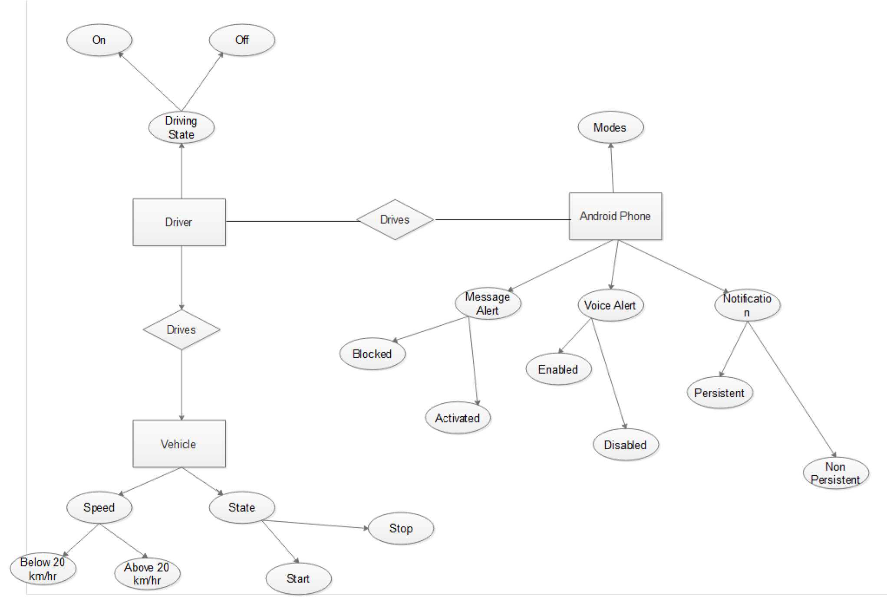

## Data Flow Diagram:

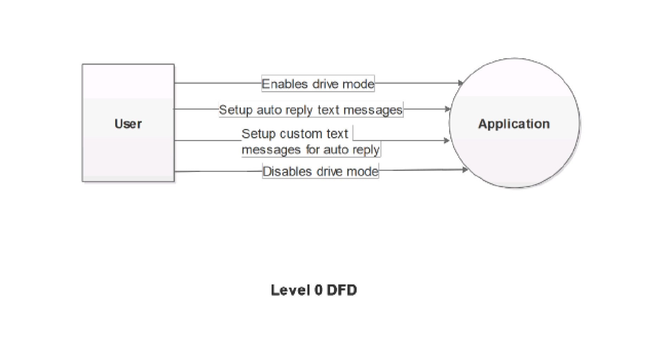

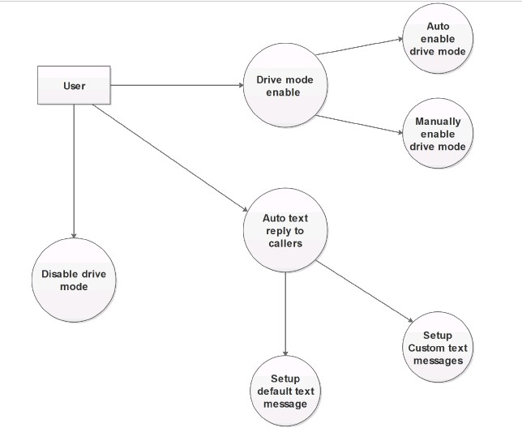

**Level 1 DFD**

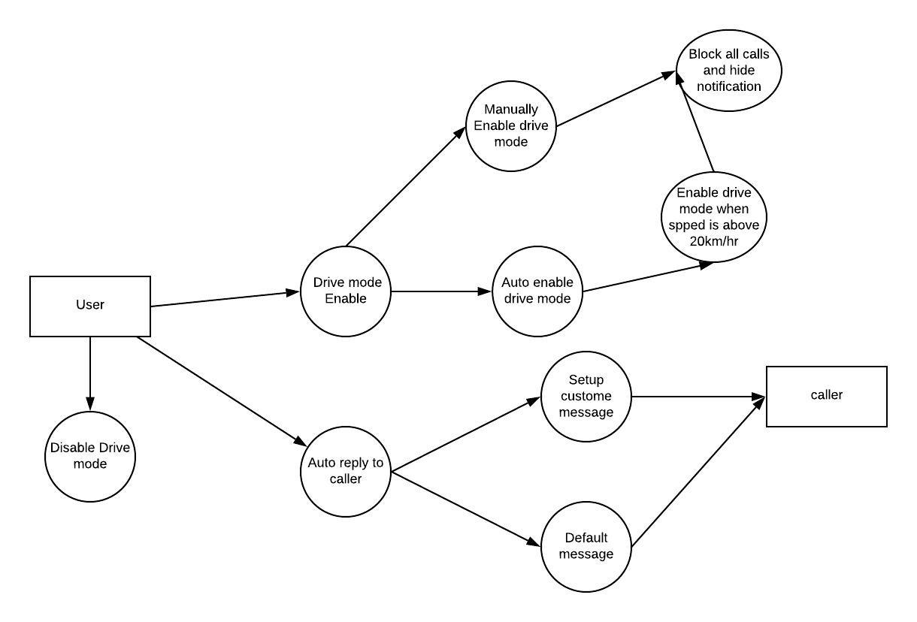

**Level 2 DFD**

**Conclusion**

Hereby, as far as our knowledge of this project goes, we assert that the mini-project on

Successful implementation would help the drivers to drive safely without any distraction.

This will help to reduce accident percentage and help in road safety.

**Future Scope**

1. **Android wear support**
2. **Parental Controls i.e. Parent will be able to keep track of speed of their children’s driving.**
3. **Car mode with navigational features.**
4. **Fuel tracking based on distance travelled and speed.**